**Aplicaciones Distribuidas NRC 23316**

Trejo Alex

Juan Pablo Pinza

Karla Ansatuña

kubernetes-dashboard

Docker hub

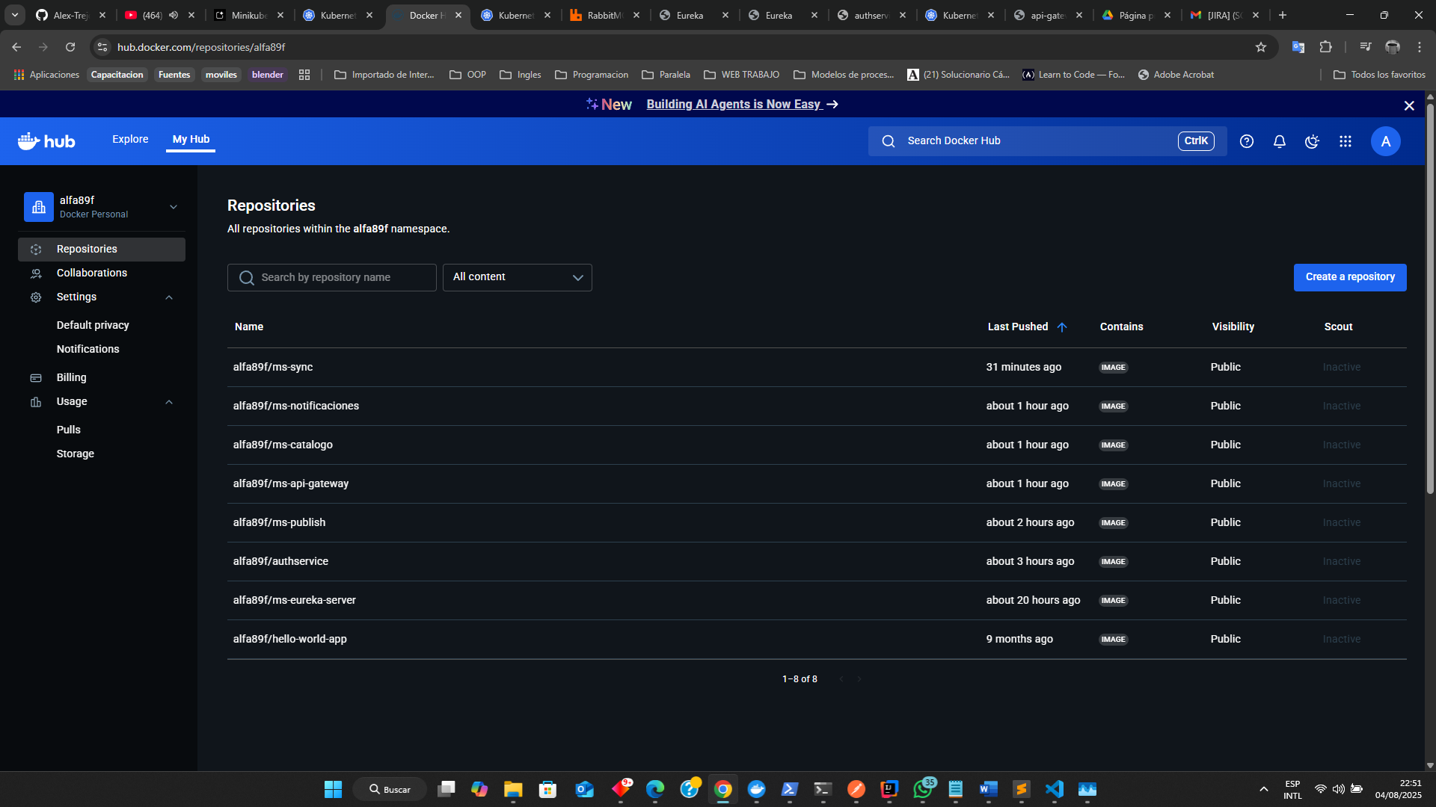

RabbitMQ

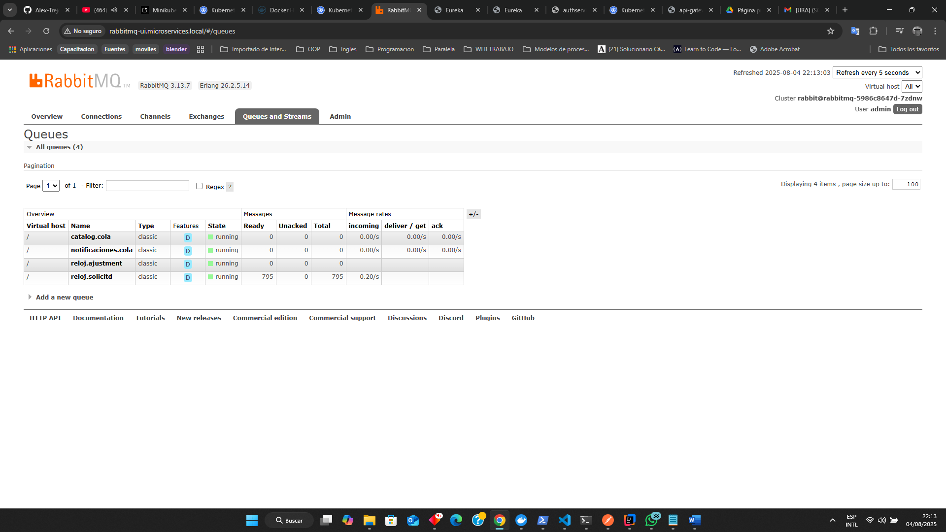

Eureka server

Ms de authservice

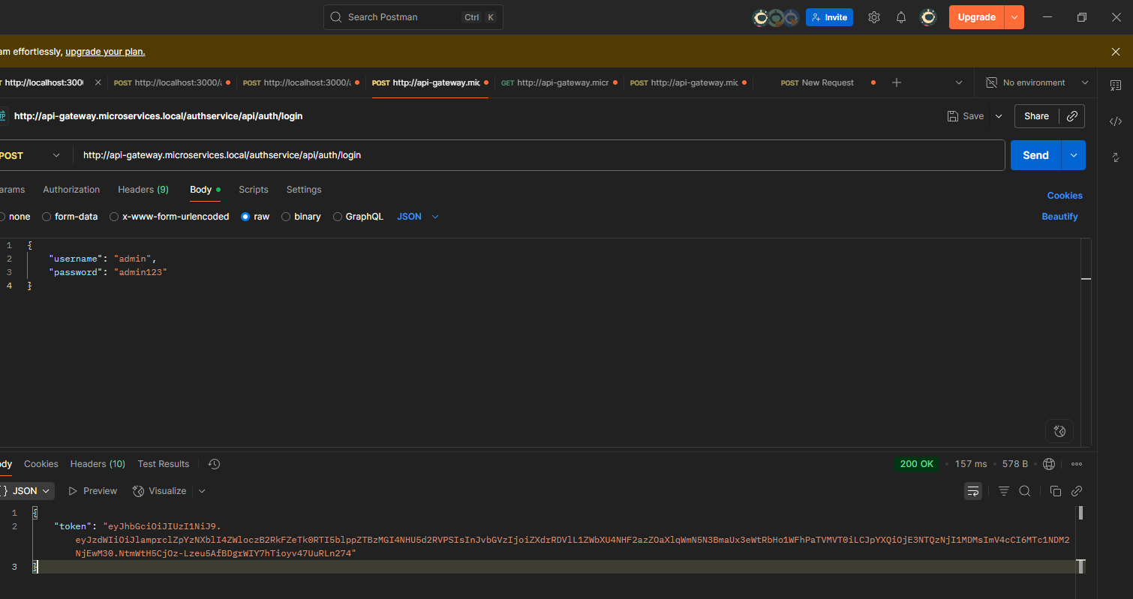

Ms de publish

Ms de catalogo

Obtén el nombre del pod de ms-catalogo:

kubectl get pods -n microservices-ns -l app=ms-catalogo

kubectl logs -n microservices-ns <NOMBRE_DEL_POD_DE_CATALOGO> -f

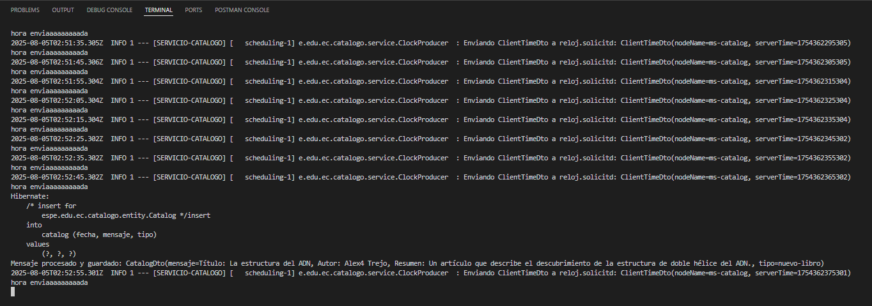

Ms de notificación

Ms de sync

